Impact of child mental health problems is worse than 40 years ago – our new study suggests
Naomi Warne, Postdoctoral Research Assistant, Cardiff University
Ruth Sellers, Senior Lecturer in Child Development and Community Health (Primary Care & Public Health), University of Sussex
July 5, 2019 1In England, rates of childhood mental health disorders have increased in the past 20 years. The proportion of five to 15-year-olds with a mental health disorder rose from 9.7% in 1999 to 11.2% in 2017, with emotional disorders (such as depression and anxiety) becoming more common in particular. Now, on average, three children in a class of 30 will have a mental health disorder.
Awareness of mental health problems has increased too, and a number of policy changes and novel treatments have been introduced to specifically target children’s mental health. But our research suggests that children with mental health problems have worse relationships with their peers, worse grades at school and worse mental health in adolescence compared to children who had mental health problems 40 years ago.
Our study takes a novel approach, by looking at changes in the impact of child mental health problems over time. We followed the lives of three cohorts of UK children born in 1958 (14,544 children), 1991-1992 (8,188 children) and 2000-2001 (13,912 children) from birth to adolescence. And compared those with childhood mental health problems (at age seven) who were born in 1958 (9.6% of boys, 8.4% of girls), 1991-1992 (7.0% of boys, 5.4% of girls) and 2000-2001 (9.7% of boys, 5.5% of girls) to see how their lives had been affected by their issues.
We were interested in how mental health problems affected several different areas of these children’s lives. These included social problems (social isolation and being bullied) at age 11, academic achievement (achieving five or more exam passes) at age 16, and mental health (problems with emotions, conduct, hyperactivity and with peers) at age 16.
We found that, regardless of what generation children were born in, those with mental health problems at age seven were more likely to have social problems at age 11. They were also less likely to achieve five exam passes and more likely to have mental health problems at age 16.

Read more: Achieving then failing in primary school is a sign of future teenage depression

Interestingly, the association between childhood mental health problems and these negative outcomes became stronger in the more recent generations. In other words, mental health problems had a greater impact on later social problems, exam marks and mental health for children born in 1991-1992 and 2001-2002 than children born in 1958. This suggests that outcomes for children with mental health problems may have become worse in more recent generations.
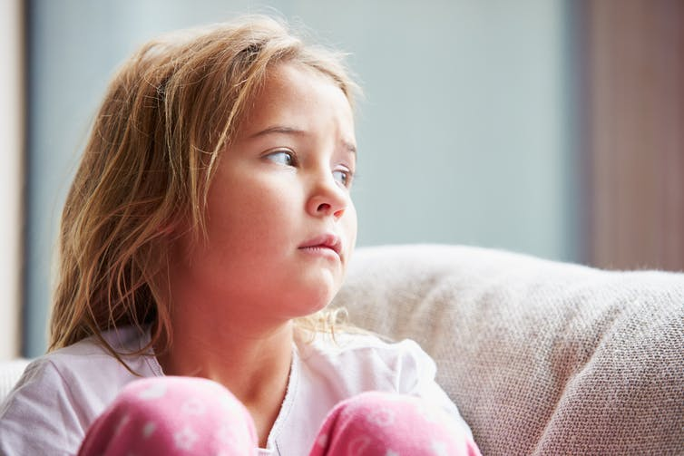Child mental health problems can have a lasting impact on school performance. Monkey Business Images/Shutterstock

What is behind these changes?
We could not directly test why mental health problems are more strongly associated with negative outcomes in more recent generations, but we were able to rule out some things that could have affected our results. Our additional analyses found that these changes were unlikely to be due to recent generations having more symptoms of poor mental health, or being more socially disadvantaged than the earliest generation.
While we don’t know why these changes have occurred, society today is very different compared to 40 years ago. Young people today are achieving more exam passes that will grant them university entry than in previous generations. According to our findings, those with mental health problems are disproportionately more likely to have poorer grades. We also know that society’s increased emphasis on academic success may come at a cost to young people’s mental health. So children from more recent generations with mental health problems may be more likely to be left behind academically.
New technology may have also contributed to the worsening of outcomes in more recent years. Research has yet to unpick whether social media causes mental health issues and associated outcomes, but high levels of social media use are associated with poor mental well-being, particularly in young girls.

Read more: Social media is not to blame for depression in young people

Social inequality in children’s physical health and mental health is widening too. So it could also be that changes in mental health outcomes are due to the most disadvantaged children in society being disproportionately affected by changes in public spending.
Other recent societal changes, such as increases in sedentary behaviour and obesity, changes in drug and alcohol use, and children entering puberty earlier, may also play a role. However, with no direct links proven between any of these factors and mental health outcomes in young people, more research is needed before we can say for certain what has caused the impact of mental health problems to get worse over time.
Whatever the cause, our findings show that more needs to be done to improve the lives of children with mental health problems. As many children with mental health problems do not access help, better early screening is vital to get them the help they need. Our research also showed that short-term follow up of children with mental health problems may not be enough. Instead, continued monitoring and access to relevant services is needed throughout adolescence, and perhaps into adulthood.
In addition, medical professionals and policy makers must consider why society today may be more challenging for children with mental health problems, and what can be done to reverse these trends.
href=https://theconversation.com

